Title

Introduction
Please customise your Styles! I need to read 130 assignments. Please allow me to experience diversity in formatting and appearance! Apply the appropriate Heading by accessing Home tab > Styles.

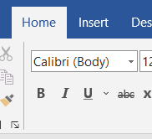 | 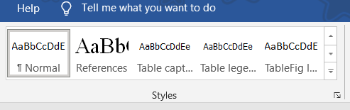

If your PC does not clash with other shortcuts, these following keys should work. Try these:
Apply the Heading 1 style.
Ctrl+Alt+1
Apply the Heading 2 style.
Ctrl+Alt+2
Don’t worry if these keys won’t work. Just use mouse instead!
To modify Styles, go to Styles, then click on a Style. By right-clicking the particular Style, you’ll be presented with Modify option as shown below.

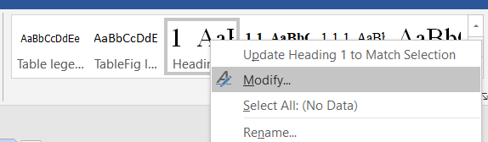

You may change the border of the table by choosing a Style as in heading as well. Click on the table. Then, you’ll see a new menu option, Table Design. Click on that and navigate/apply a Style. I would do this at the very end of writing/editing stage. I need to keep the border to mark as a place holder to make the editing job easier!
 | 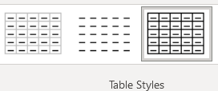

Why bother? Still many businesses and academia heavily rely on Word documents although some tech-savvy souls may prefer LaTex or other formats. If you collaborate with other people, you will certainly benefit from being familiar with Word Styles that other organisations use! It won’t hurt!
Also, for those who are curious about Rmarkdown (just skip this part if you are not familiar with Rmarkdown), learning Word Styles is a good basis for Rmarkdown. Trust me, with a relatively short training, you’ll be much more flexible in producing beautiful Word documents from running Rmarkdown, rather than figuring all complex options to produce PDF output! Yes, you need to learn Styles first, not Rmarkdown. This way, you’ll fully utilise Rmarkdown to your taste!
By the way, in Introduction section, you state what this report is about (Not the instructions on how to use Styles!). The purpose/rationale of the report. For details, please consult the document “Assessment2_Instructions.pdf”.

Preliminary Data analysis

Sample characteristics
Provide a descriptive statistics table

Data visualisation
Explain what relationship between which variable you’re exploring. State why.

Heading 3 (Data visualisation subsection)

Heading 3 (Data visualisation subsection)

T-test
Follow the instructions in the document provided on BB.

Correlation analysis

Regression analysis

Subsection 1

Subsection 2

Discussion and Conclusion
Summarise your findings, key messages, limitations of the analysis, etc.

Before submission, ensure to check spelling! Good luck!

References

Appendix (R code)

